Building on the problem–solution framing above, the next section justifies why this visual approach is appropriate for managerial decision-making.
Fit of the Visualization Technique
The visual analytic techniques employed by our dashboard significantly enhance both internal and external value for our organization.
Internally, the dashboard streamlines decision-making by turning complex datasets into interactive insights, allowing rapid identification of profit drains and high-margin opportunities (Khatri and Gupta, 2022).
Externally, visual analytics communicate transparent narratives to retail partners and investors, evidencing disciplined margin management and supporting controlled experimentation (Khatri and Gupta, 2022).

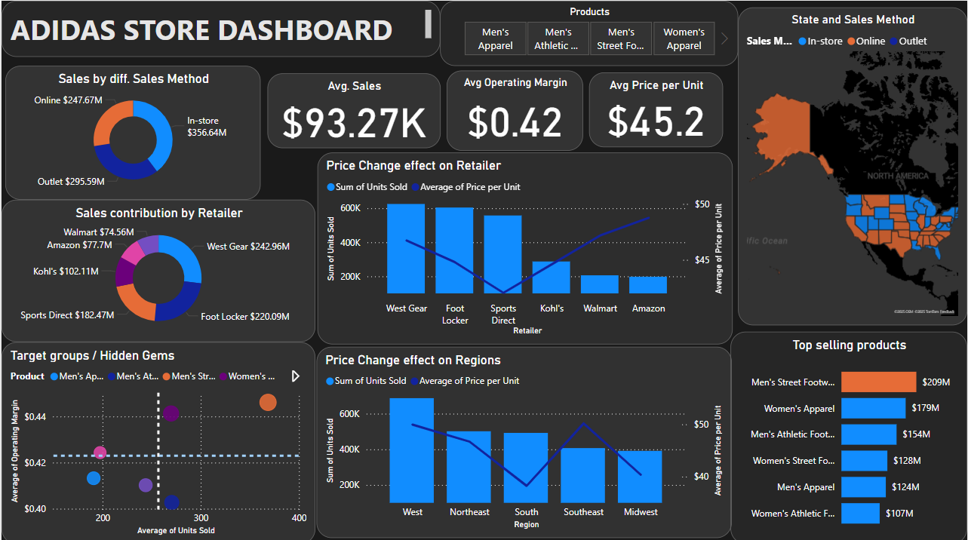

Demonstration of Visualization
The dashboard integrates product performance and market responsiveness to address the problem of hidden margin erosion. KPI cards report average sales, average operating margin (percentage), and average price per unit for the selected period, establishing baselines for comparison. Sales by Method and Sales Contribution by Retailer summarise revenue mix, while the state map shows geographic distribution by sales method; all three visuals cross-filter the page to keep context consistent. This visual clarity allows managers to strategically promote profitable products and set optimal prices, ensuring sustainable profit growth rather than merely increasing sales numbers.
The dashboard addresses these challenges through strategic segmentation that supports rapid interpretation and action. It employs a profit-volume quadrant to categorize products clearly into four distinct groups, enabling managers to understand each product's strategic role rapidly.
Products such as Women’s Athletic Footwear emerge as hidden gems—items that sell in lower volumes yet yield high profitability per sale. By visually positioning these products in the top-left quadrant, the dashboard immediately highlights opportunities for increased promotion and bundling strategies, aimed at driving higher unit sales without sacrificing margin.
Conversely, products like Men’s Street Footwear and Women’s Apparel fall into the Stars quadrant, indicating strong sales coupled with robust profit margins. The visual representation emphasizes the importance of maintaining prominence for these items through consistent stock availability and optimal retail placement.
The Volume Drains quadrant, containing Men’s Athletic Footwear, signals products that, despite high sales, yield relatively lower margins. Visualization quickly pinpoints opportunities for cost management strategies such as supplier renegotiations or incremental pricing adjustments. The dashboard facilitates these insights without the need for detailed numeric analysis, ensuring rapid and informed decision-making.
Finally, the Low Performers quadrant depicts products such as Men’s Apparel and Women’s Street Footwear, indicating both low sales volume and profitability. Managers can immediately consider inventory reduction or clearance strategies. By highlighting these products visually, the dashboard helps prevent resource misallocation toward unprofitable inventory.
Further, the dashboard effectively addresses market-specific pricing sensitivity through an interactive, retail scatter. Managers can swiftly detect state and retailer responsiveness to price changes, translating abstract price elasticity concepts into actionable insights. Overlaying trends allows precise market-level interventions, avoiding blanket pricing decisions that may inadvertently harm profits.
By integrating product profitability and pricing sensitivity into a unified visualization, managers gain a cohesive understanding of how strategic pricing decisions impact product profitability across different markets. This holistic perspective encourages an integrated approach where pricing and product strategies reinforce each other, ensuring decisions are not made in isolation but as part of a broader profit optimization framework.
Interactions are intentional: selecting a product from the top slicer filters all visuals; choosing a state or retailer updates the price–volume views to the same subset.

Recommendations
The patterns revealed by the visuals translate into the following decision rules and process changes:
Embedding the profit–volume dashboard in routine workflows converts descriptive insight into prioritised merchandising actions. High-margin, high-volume stock-keeping units should receive priority replenishment, whereas persistent loss-leaders ought to be phased out (Tawil et al., 2024). Elasticity-based rules should cap markdowns and set minimum price floors, while integrating customer, inventory and marketing feeds into the analytic layer will surface bundling opportunities. Finally, analyst upskilling and weekly data-driven review meetings will embed an experimentation culture across buying, pricing and supply-chain functions (Wang et al., 2022).

Roadmap
To embed these rules, the roadmap sequences near-term actions into medium-term capability development.
Horizon | Focus Areas | Why it matters
0–3 months | Product focus  Pull the draining SKUs in the low-margin--high-volume quadrant and hold all markdown funding on them.  • Redirect the marketing budget to the three high-margin / low-volume “hidden-gems.”  Pricing focus  • From the retailer scatter, flag price-sensitive retailers as price-sensitive and impose a halt on list-price rises.  •Suggestion for a price lift at West Gear and Foot Locker, which sit above the elasticity trend line. | The dashboard already shows which SKUs drain profit and which retailers absorb price. Acting immediately locks in a quick EBIT(Earnings before interest and taxes) lift with zero new data collection (Mărcuță, 2025).
3–9 months | Product focus • Run cost-renegotiation meetings with suppliers of the low-margin SKUs.  Pilot Bundel selling(e.g., Women’s Athletic Footwear + apparel add-on) in the two least price-sensitive retailers; measure.  Pricing focus • Use the combo chart to launch A/B price tests by state: Feed weekly results into trading meetings and adjust trend-line targets. | Builds a test-and-learn loop; the dashboard’s real-time view lets teams see if renegotiations and bundles actually shift quadrant position or elasticity slope (Lukas Erbrich et al., 2024).
9–18 months | Include return rates and storage costs when calculating how much profit each product actually makes.  If any product still sells poorly and makes little real profit after all the earlier changes, stop selling it.  Use a smart pricing tool that checks how sensitive each state is to price changes, and automatically suggests small price updates every week. | Prices shouldn’t be “one size fits all.” Some states can handle small price increases without losing customers, while others are more sensitive.  Adopt automated pricing tools that incorporate state-level elasticity to recommend incremental adjustments (Lukas Erbrich et al., 2024).

Key Takeaways & Conclusion
The Adidas dashboard summarises three findings. First, profit-volume segmentation demonstrates that a small cluster of high-volume SKUs suppresses margin, whereas less visible “hidden gems” generate superior contribution profit. Promotional resources should therefore be redirected. Second, elasticity charts reveal precisely where selective price increases will enhance earnings and where caution is warranted, replacing uniform pricing with targeted action. Third, the phased roadmap links immediate measures. Occasional outliers, such as clearance events, may skew results, necessitating periodic data validation. Despite these limitations, the dashboard's visual analytics fundamentally enhance internal efficiency and external transparency, equipping our organization to pursue sustained profitability through strategic and informed decision-making. Periodic data validation remains essential to account for outliers. Despite this, the dashboard improves internal efficiency and partner transparency, supporting sustained, evidence-based profitability

References:
Erbrich, L., Wellbrock, C.-M., Lobigs, F. and Buschow, C. (2024) ‘Bundling digital journalism: Exploring the potential of subscription-based product bundles’, Media and Communication, 12. https://doi.org/10.17645/mac.7442 (Accessed 31 July 2025).
Khatri, A. and Gupta, N. (2022) ‘Impact of data visualization on management decisions’, London Journal of Research in Management and Business, 22(5). Available at: https://journalspress.com/LJRMB_Volume22/Impact-of-Data-Visualization-on-Management-Decisions.pdf (Accessed 20 July 2025).
Mărcuță, C. (2025) ‘Creating impactful data visualizations: A retail case study breakdown’, Moldstud. Available at: https://moldstud.com/articles/p-creating-impactful-data-visualizations-a-retail-case-study-breakdown (Accessed 31 July 2025).
Tawil, A.-R.H., Mohamed, M., Schmoor, X., Vlachos, K. and Haidar, D. (2024) ‘Trends and challenges towards effective data-driven decision making in UK small and medium-sized enterprises: Case studies and lessons learnt from the analysis of 85 small and medium-sized enterprises’, Big Data and Cognitive Computing, 8(7), 79. Available at: https://research.aston.ac.uk/en/publications/trends-and-challenges-towards-effective-data-driven-decision-maki (Accessed 20 July 2025).
Wang, J., Huang, Y., Compiani, G., Hsiao, C., Powell, J., Yang, C., Yang, S. and Zeng, G. (2022) ‘Scalable nonparametric price elasticity estimation’. Working paper. Available at: https://bpb-us-e2.wpmucdn.com/sites.utdallas.edu/dist/8/1090/files/2023/02/scalable_nonparametric_price_elasticity_estimation.pdf (Accessed 31 July 2025).

